

**COUNTER-CROWDED**

**PROJECT REPORT**

JANUARY 2022

**GROUP 20**

Ali Çelik 210104004219​

Ziya Kadir Tokluoğlu 210104004228

Burak Kurt 210104004225

Elif Deniz 210104004239

Taha Eren Şahin 210104004214

Arda Çaltepe 210104004243

Mehmet Sarış 210104004234​

**Contents**

**1. Summary…………………………………………………3**

**2. Problem Description …………………………………….3**

**3. Project Set-Up …………………………………………...3**

**4. How Counter-Crowded Operates? …………………….4**

**5. Outputs and Benefits…………………………………….4**

**6. Inputs and Outputs……………………………………..4**

**7. Results…………………………………………………….5**

**8. Conclusions……………………………………………….5**

**9. System Block Diagram…………………………………..5**

**10. Group……………………………………………………6**

**11. References……………………………………………….6**

**1. Summary**

Counter-Crowded is a project made using Arduino. It is designed with the limitations of the person in the Covid pandemic in mind. It counts the people entering the area and informs the situation with LED lights, LCD screen and buzzer on it. It aims to provide follow the rules and raise awareness.

**2. Problem Description**

The Covid19 pandemic, also known as the Coronavirus pandemic, is ongoing global. Authorities are taking critical measurements to stop the spread. One of these measures is the social distancing rule. The problem is based on social distancing rules, and this rule should be obeyed worldwide. That is why governments set some limitations on the number of people in closed areas. The source of the problem is this limitation. How can people inside of closed places be counted? How can these people be warned when the number of people in the area is out of the limit? Therefore, these questions need to be solved conventionally or technologically to protect public health and safety.

**3. Project Set-Up**

* Arduino Uno—Controller
* 2 x HC-SR04 Ultrasonic Distance Sensor—Sends sound waves to surface for detection
* LCD 16x2 with I2C-- Screen for output
* 2 x Breadboard--Device for connect the components
* 9V Battery & Battery Compartment—Provides power supply the components
* 2 x RGB—Lambs for visual warning.
* Buzzer—Makes auditory warning
* 4 x 330 Ω Resistance--
* Jumper Wires—Cables for connect components of project

4. **How Counter-Crowded Operates?**

Arduino detects the mobility under the door and processes that input then sends output to the LCD screen as “Leaves” message and decrements the quota by one in the LCD screen. Also, Counter-crowded provides a control mechanism to prevent simultaneous entrance. When an entry is detected, exit led turns led, and entrance led turns yellow. These mechanisms specify that the people who want to enter that place should wait until LEDs turn green. Therefore, Counter-Crowded gives information about the situation by providing visual and auditory warnings and creates awareness for social distancing rule in closed areas.

5. **Outputs and Benefits**

**Output**

* Counter-Crowded Project

**Outcome**

* Less Covid19 spread in closed areas

**Benefits**

* Preventing from the people counts in closed spaces exceed the maximum number of people should inside.

6. **Inputs and Outputs**

**Inputs**

* HC-SR04’s ultrasound receiver (echo pin) receives the reflected sound (echo).

**Outputs**

* HC-SR04’s ultrasound transmitter (trig pin) emits a high-frequency sound (40 kHz).
* LEDs light up red, green or yellow depending on the situation.
* LCD screen displays quota status.
* Buzzer makes sound for auditory warning.

7. **Results**

# The project's primary purpose is to limit the spread of Covid19 by following the rules about limitations in the number of people in closed areas. However, we cannot provide any real-time results about the effect on the spread. The project includes all visual and auditory warnings, as we can see in the video. It warns of excess quota and provides control mechanisms for any entry and exit activities. As a result, our project ensures the necessary controls for implementing the limitation of the number of people in closed areas.

8. **Conclusions**

# Social distance is an important factor in reducing the spread of covid. For this reason, important to follow social distance rules in all closed areas but this rule is difficult to follow. The aim of the project is to ensure that this rule is followed and monitor the number of people in closed areas and warn them for excess quota. Thanks to the project we aimed to reduce the spread of the virus by monitoring the number of people in closed places.

9. **System Block Diagram**

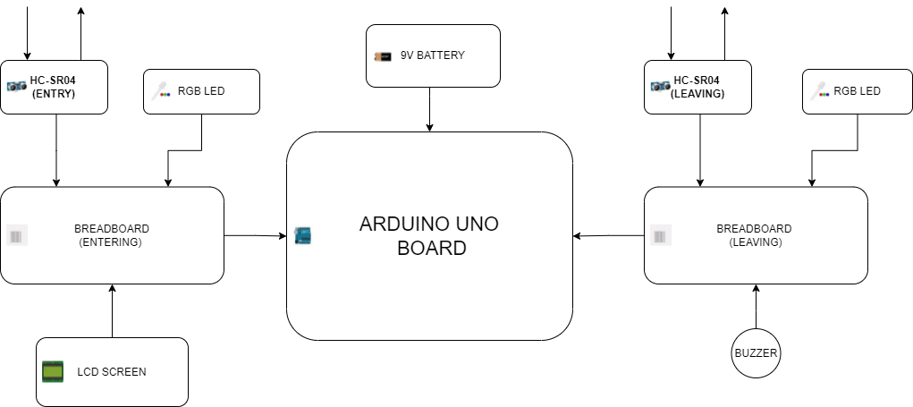

10. **Group**

Ali Çelik - Coding Part

Mehmet Sarış - Coding Part

Ziya Kadir Tokluoğlu - Coding Part

Burak Kurt - Coding Part

Arda Çaltepe - Presentation Part

Elif Deniz - Presentation Part

Taha Eren Şahin - Presentation Part

11. **References**

Some codes of LCD screen

(<https://www.projehocam.com/arduino-lcd-i2c-protokolu-kullanimi/> Date of Access 6 January 2022)

Some codes of RGB LEDs

(<https://maker.robotistan.com/rgb-led-nedir-arduino-kontrolu/> Date of Access 6 January 2022)